Trainee manager

The purpose of the application is to manage a list of trainees based on their cohort code. This will be a menu driven console application which will have the following options

1. Register trainee: add a new trainee to the repository
2. Remove trainee: remove an existing trainee from the repository
3. Find by name: find if a trainee is present under the cohort
4. Find all: find all trainees in a cohort

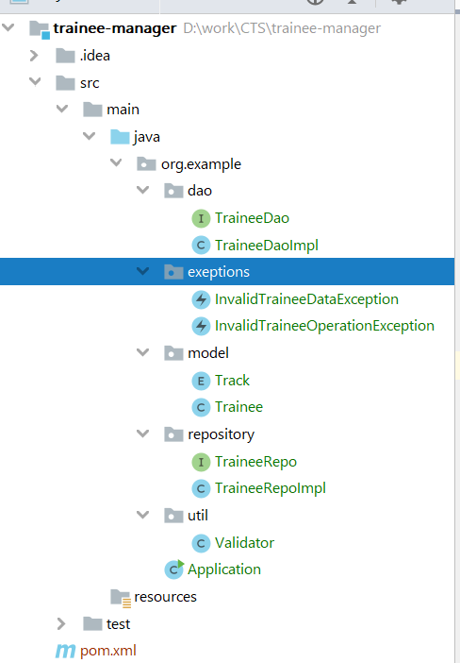Data validation constraints

1. Make sure email is in correct format
2. The name fields cannot have numeric data
3. Empid has to have 6 numbers
4. Cohort code should be in the following format, AAAXXAAXX, A is for alphabet and X is for number

Any data validation error must raise an *InvalidTraineeDataException*

A trainee cannot be added in more than one cohort, in case an attempt is made to add a trainee to more than one cohort and *InvalidTraineeoperationException* must be thrown

Requirements

1. Use Lombok to add getters, setters, and constructors in the Trainee model class.
2. Set the root logging level to *INFO*
3. Every output message to the user must be logged via *ConsoleFileAppender*
4. Console logs should have the following format, [*timestamp*] – [*message*]
5. File logs should have the following format, [*timestamp*] – [*thread*] [*level*] [*logger*] [*message*]
6. All the method calls must be logged in the *activity.log* file
7. All the errors must be logged in the *error.log* file
8. Error log should include the error stack trace as well
9. Make sure the log files are kept inside a folder names logs
10. Use a *RollingFileAppender* for the log files and it must be rolled based on time
11. Perform code quality analysis using sonarqube